


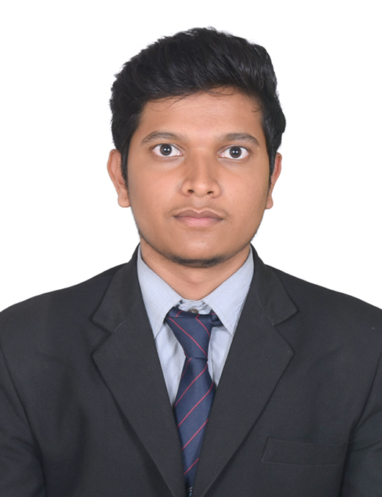

Education
Diploma in Computer science & Engineering
Hindustan Electronics Academy,

12th
Lady Vailankanni PUC College,
2025

SSLC (10th)
Mishra Residential Public School,
CBSE,
2023

Skills
- Coding
- Java, SQL
- Debugging
- Microsoft Office
- Spreadsheets

+91 6207059206
sujalmandal308@gmail.com
linkedin.com/in/sujal-mandal-1-06011a438

Contact

SUJAL MANDAL

CAREER OBJECTIVE

To begin my career in a reputed organization where I can apply my skills and knowledge gained during my diploma and grow professionally.

TECHNICAL SKILLS
- Basic knowledge of Software Tools
- Knowledge of Computer Network, Computer Hardware & Maintenance Application
- MS Office Word, Excel, PowerPoint
- HTML, CSS

EXTRA-CURRICULAR ACTIVITIES
- Member of IIC (Innovative Institution Council)

PERSONAL PROFILE
- Father Name: Mukesh Mandal
- Date of Birth: 06th of Feb 2008
- Gender: Male
- Language known: English, Kannada, Hindi
- Nationality: Indian
- Hobbies: Drawing, Cricket
DECLARATION
I hereby declare that the above-mentioned information is true and correct to the
best of my knowledge and belief.
Date: 09/09/2026 Signature
Place: Bangalore Sujal Mandal

